Report for CP3109

Hanoi Summer School

Song Yangyu

(A0077863N)

# Impression

I attended the Hanoi Summer School this summer, from 20th June to 26th June. During our study there, we took 4 days of crush lecture on the topics of: Cloud Computing, F# Programming Language, Cryptographic Protocols & Applications, and GPS System. Besides of that, we also made a trip to Ha Long Bay, tour around Hanoi led by the local students, make a company tour to local software company FPT. From that experience, we not only learnt about the knowledge taught from the lecture, but also learnt various aspects about Vietnam.

In this report, I’ll first talk about what we’ve learnt form the lectures during the summer school, then talk about Vietnam from the aspects of food, transportation, street vendors, buildings, and labor.

# The Summer School Lectures

## Cloud Computing

The lecture starts with the principles of cloud computing: definition; key characters – parallel computing, virtualization; on demand self-service and scalability; cloud delivery models and their characters (which are quite basic): public cloud, private cloud, hybrid, and community cloud; Service models and corresponding service provider: Software as a Service, Platform as a service, and Infrastructure as a service.

It goes on with a deeper discussion over the use cases, the pros and cons of different service models; and studied the Amazon EC2 as an example. I feel that for this part, because we didn’t try much on the Cloud Computing service, while the characters are more like common sense, it’s quite dry.

Then topic suddenly switch to parallel computing with a simple example: calculating PI. This is like an example would be go through by every Operating System course. The further discussion is about MPI and Map-Reduce, which I don’t really understand because not having much experience on parallel programming; I cannot appreciate the beauty of MPI and Map-Reduce yet.

## F# Programming Language

This is a crush course on F# programming language: from setting up the programming environment (I did successfully set up the environment on my MacBook Pro during the lecture), to the data types and functions, then it comes some basic characters about F#, which is quite like Haskell or Ocaml: pattern matching, Lazy Evaluation, Modules; then its imperative features like mutable locals, records, and library. In the end, we talked about the OOP of F# and other features.

I can understand the lecture 1~4, because I have a bit of prior experience with Haskell. But I found it hard to understand the lecture 5, the workflow and parallelism part.

As a summery for this F# language, I think F# is like Ocaml + .Net library.

## Cryptographic Protocols & Application

This lecture processed quite slow, but the good thing is that the lecturer does make sure that the people who are listening do understand the topic before proceeding.

From this lecture, we’ve learnt about the evolution of a good cryptographic algorithm: from the secret-key cryptography, to Diffie-Hellman’s public key method, to Needham-Schroder’s Authentication and Key Exchange method, to Denning-Sacco’s Modification on Needham-Schroder’s Authentication. After building up the basic understanding on the system, we learnt about its use case among the communications of user, ATM and Bank.

Although the lecturer only managed to finish around 2/3 of the planned, I feel that I got deeper interest into this subject.

## GPS System

We first learnt about the basics of using signal to measure the distance, then about the signal processing process of the GPS; then we proved mathematically that in order to compute the position, we would need at least 4 satellites using Linear Algebra. Later part of the lecture is about different standard of the GPS system (European standard and the American ones), which I don’t quite understand.

Then the lecturer showed their current study on the GPS system: we went to the roof of the building, try to gather data using the device, and do a real-time calculation. After several times of trial and error (because the device is still underdevelopment by a PhD student), they finally caught a bunch of correct data.

# Different Aspects of Vietnam

## Food in Vietnam

Food one of the main theme we had in Vietnam. When in Vietnam, nearly all kinds of food we’ve tried differ from meal to meal. Nearly every time time after a meal, we’ll take desert: drink with some sort of real fruit.

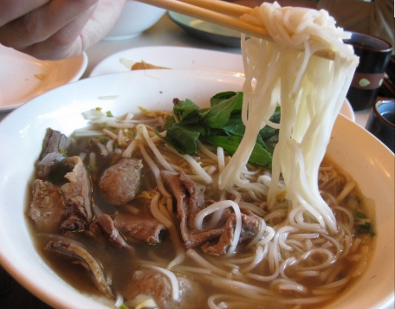Vietnam food is very healthy: there’re lots of meals come with a plate of vegetables: be it different kind of leaves (with some special flavor like mint), or cucumbers. Here’re some good examples:

Beef Noodle, called as “Pho Bo” in Vietnam language, is the most commonly seen food on the street. The noodle is made of rice, which I’ve never seen from other places before. This is very good for a breakfast. Usually, one bow of beef noodle is around 20,000 VND, which is approximately 1 USD.

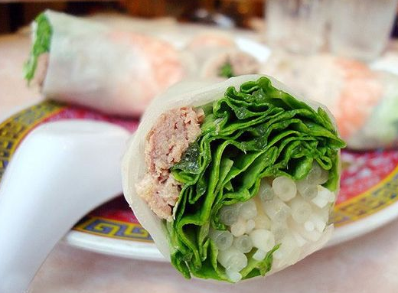The Vietnam Spring Rolls can be eaten directly, or comes as a side dish comes with some special source. It’s quite easy to make: first prepare and mix the necessary raw material: vegetables, meat, salt, chicken essence; then use the special made very think pancake to role the raw materials; then put it into the boiled oil and fry for a short while. Then you can take it out and eat : ). It’s very crispy and delicious.

## Transportation in Vietnam (Hanoi)

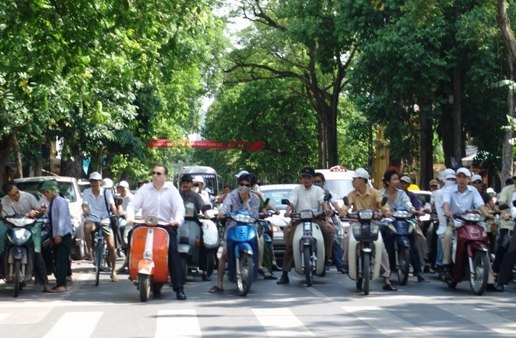There’re mainly three kinds of private transportation in Hanoi: motor bike, car, and bicycle.

Motorbike is the most commonly seen method of transporting here; while the car and bicycle are very les often seen comparing with the huge amount of motorbikes. Lots of riders and drivers don’t quite obey the traffic rules (like give ways to the passenger on the zebra cross, or waiting for the red light).

Therefore, it’s quite hard for newcomer to cross the road: nobody will stop for you if you just stand beside the road. If you really want to cross the road, you can just ignore most of the motorbikes and walk with a constant speed, and try to avoid the cars. The drivers and riders would avoid you, and you can finally successfully cross the road. If you still dare not to cross, you can just try closing your eyes can cross.

As for the public transportation within the city, there is quite a verity: taxi, motorbike, bus, human motored tricycles, etc.

For a tourist, taxi is the most commonly chose one. The taxi is managed under different crops, and their price differs also. Most of the taxi drivers do not speak English (therefore it’s quite hard to communicate), and some of the drivers are dishonest: some of them would give you a Hanoi city tour if you don’t know the route. For example, once we toke two taxi travelling from one place to another; one group of students spent around less than 100,000 VND and half an hour; while another group spent around 180,000 VND, and more than an hour. This is nearly twice as expensive!

While for the more public transport: there aren’t many buses on the street (probably most people are taking a motor bike); and the signboard for the bus is not so obvious. Moreover, there’s currently no subway (or MRT) currently in use. I think the Vietnamese solved their problem mostly through motorbike and bicycle.

## Street Vendors in Vietnam

The street vendors in Vietnam are quite free style: plastic table with small plastic chairs for the “have-it-here” food, or a box on a bicycle for selling the fruits.

The food street venders usually come out during lunch / dinner time, setup a small cooking place, and go back when they finish the sales for this time. The food here is usually quite good, and very native.

You can also see some “fruit street vendors”. They sell salted fruit with chili (quite unique). You can usually see several people take a small fruit-break during non-meal time. I think it’s a good way for people to talk with each other also.

If you buy from the on-the-go fruit vendors, they can even help you to peel off these fruits.

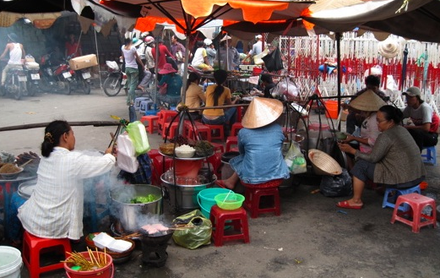

## Buildings in Vietnam

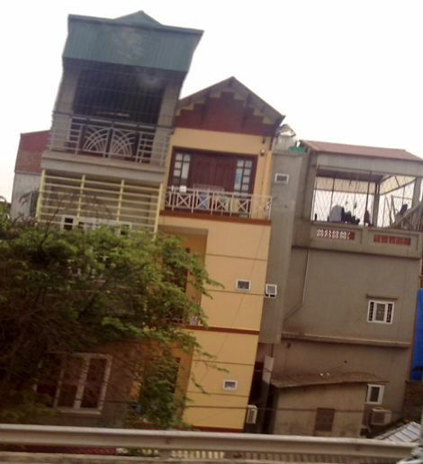When in Vietnam, we can usually see buildings as in the picture on the right. These buildings are quite narrow, but very tall.

These are formed over time. In Vietnam, people can own a private land, and they can build their own house there.

Over time, when they becomes richer, they’ll try to extend their house to higher level, and some people would use the first floor for business. But they can only use their own land (which is usually small); therefore, they’ll grow their old house to higher level, and finally it becomes like this.

Also because of the “private land” issue, the whole city looks quite messy – without a central planning. But people here seem to be really enjoying where they live: they have a good place of their own, and it’s not that expensive to make.

## Labor in Vietnam

The labor cost here in Vietnam is quite low. For an educated person, like a school teacher would earn around 3,000,000 ~ 5,000,000 VND, which is approximately 144 USD ~ 240 USD. The salary for a technical is higher. For example, a programmer would earn a salary of around 500 USD per month, and that’s considered as a good salary already.

The local university’s degree is not accepted other countries; but their education seems to be quite good (according to my several day’s summer program there). Because of this, there’re some companies doing some out-sourcing business.

# Conclusion

From my trip to Vietnam, I not only learnt about the knowledge on computer provided by the summer school, but also learnt about the living style and opportunities here in Vietnam.

I can see that with little intervention from the government, people here are still living a “free-style”: it’s quite messy everywhere, but there’s inner balance formed over years of practice by everyone to make sure nothing goes wrong.

However, with the great need for development here, and the low labor cost, I believe that Vietnam is a good place for doing investment in the future.

# Image Sources:

Beef Noodle Picture:

<http://blog.163.com/mongmong_huang/blog/static/4000951120091274330313/>

Vietnam Spring Roll Picture:

<http://www.chinabaike.com/z/tour/2010/1209/7373.html>

Vietnam Street:

<http://www.minube.cn/photos/place/152/1070>

Street Vendor:

<http://kiat.ongs.info/files/tag-vietnam.html>